Mental Illness and the Law:
Defending Autonomy vs.
Advocating for Treatment

Please join the Hometown Bar Association for this month’s meeting
on challenging ethical and legal issues involving mental health and
the impact on the criminal justice system.

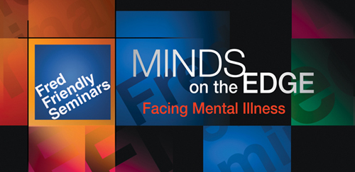

Excerpts from MINDS ON THE EDGE: Facing Mental Illness,
a Fred Friendly Seminar produced for PBS,
will introduce the issues for a panel discussion led by
Professor Joe Smith, Hometown University Law School
with
(name, title)
(name, title)
(name, title)

HOMETOWN CONFERENCE CENTER
45 Main Street, Hometown
October 15, 2009
7:30-9:30 pm

www.mindsontheedge.org

Funding for MINDS ON THE EDGE: Facing Mental Illness provided by the Alfred P. Sloan Foundation to enhance public understanding of
science and technology in the modern world. Additional Funding for outreach initiatives provided by the van Ameringen Foundation.

